**Testing Play New Song Feature**

Step #1: Correct URL

* Make sure the URL is set to development mode with the following url: <http://localhost:8080/?devel=True>

Step #2: Click Browse Files button

* 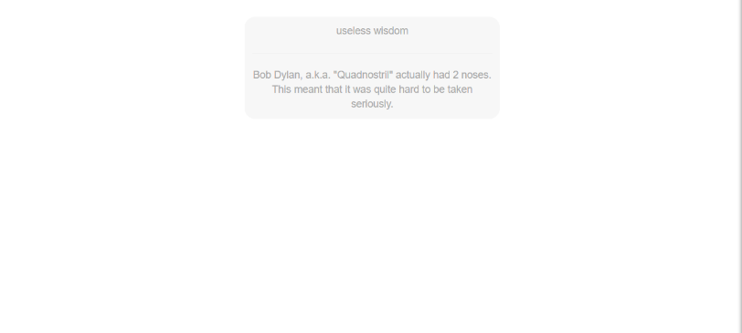On bootup your song browser will be blank like the figure below
* Clicking the browse files button in the top left of the browser
* 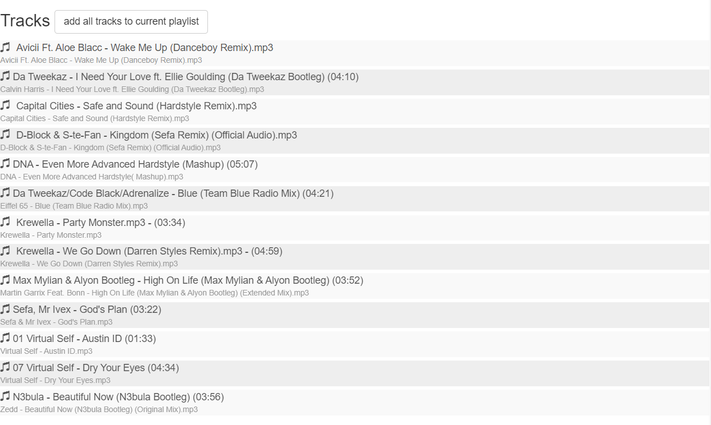Clicking that will then populate your song browser with songs (this will not work if songs are not in your directory you gave during cherry music setup)

Step #3: Add songs to the queue

* 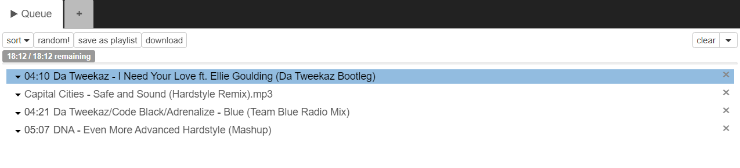Add a couple different songs to the queue to fill it. For this I’m going to add 4 songs. You can add songs by clicking on the song you want to add once.

Step #4: Double click on song to try new feature

* Click play to start listening to a song
* 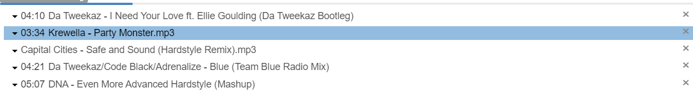Then double click on a different song to try the Play New Song Now feature. The song should be added next in the queue and then skip the current song you are on.
* 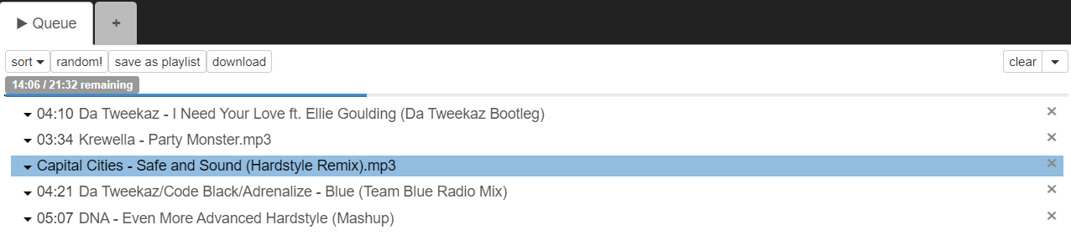Skip the song and verify the next intended song in the queue is playing next

Step #4: Add as the last song

* Next, we need to use the feature with the last song in the queue playing.
* 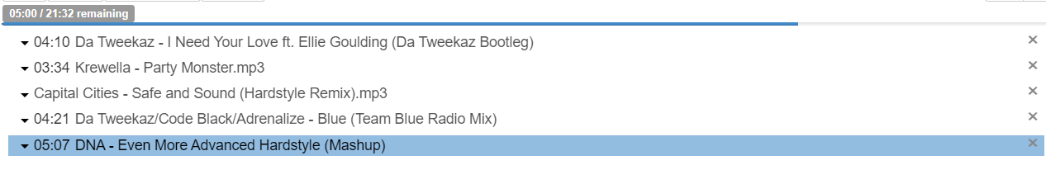Start playing the last song in the queue
* 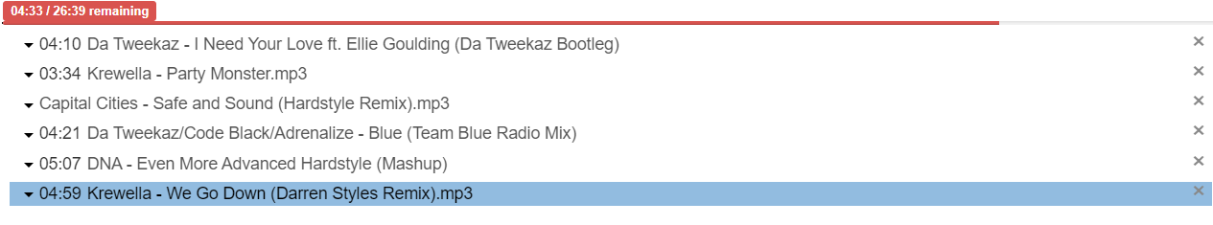Now double click on a new song and verify its working as intended

Step #5: Add as the first song

* Finally, we will test using the feature with an empty queue
* First, we will clear the queue with the clear button in the top right of the song queue
* Now double click on a song and verify it is added to the queue (it might not play instantly that’s another issue with the queue and jplayer)